Motivational Game Plan: Part 1 Investing In Your Team Worksheet

Hometown Cars Company Profile:
Hometown Cars is a small, full-service car dealership. They offer new car sales, used car sales, and a parts and service department. Recently, the general manager left the organization, and all of the departments have been struggling to meet their profit goals. Last week you were hired as the new general manager. You understand that some big changes need to be made to turn around the company’s profits. And to do this, you’ll create a Motivational Game Plan that will help optimize the team’s performance. The first step in this process is to identify how the company can invest in its team members.

Please do the following:
This assignment has 3 parts. Answer the questions in Part 1, then complete the table in Part 2 and answer the questions in Part 3.

PART 1: Investing In Your Team
You’ve talked to the Hometown Cars employees one-on-one to see how they feel about their current work environment. Below are 3 observations that employees have shared. For each of these observations, write 1-2 sentences detailing 1) the type of investment you will use (Supporting Growth Mindset, Job-sculpting, or Work Flexibility) and how you will use it to invest in your team. (See the Coach’s Huddle in Week 3 for a refresher on investing in your team.)

Growth Mindset: Growth mindset means you believe that you can improve (or “grow”) abilities such as intelligence, talent, and skills through hard work and self-discipline.
Job-sculpting: Job-sculpting means developing an employee’s role so that their work duties match what they are passionate about; what interests them.
Work Flexibility: Work flexibility means allowing employees to work when and where is best for them, as long as they get the job done.

EXAMPLE SCENARIO: Your assistant manager, Jorge, shows potential for being a general manager. One day he
mentions that he really enjoys the financial side of managing.

EXAMPLE RESPONSE: Job-sculpting. I would give Jorge the opportunity to take ownership of tracking invoices for the company.

- Employees tell you there doesn't appear to be the option for personal career development at Hometown Cars. For instance, competition within the sales department prevents seasoned sales associates from mentoring new sales associates, and the company doesn’t offer any formal training.

- A few of the sales associates have emphasized that they are car enthusiasts and take a genuine interest in how the cars they sell perform. However, because of the animosity between departments, they’ve never been allowed to really explore the cars they sell.

- Employees share that they are stressed because it feels like there is little opportunity to take care of important personal issues - like keeping up with doctor’s appointments and attending their children’s school functions.

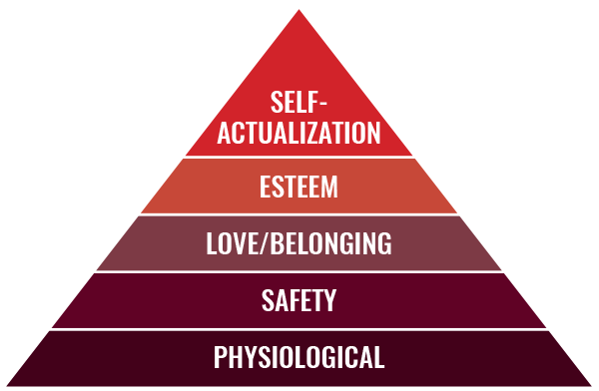
PART 2: Satisfying Intrinsic & Extrinsic Needs

Choose 1 of your responses above. Now, fill in the chart below to identify the level and needs from Maslow’s Hierarchy of Needs pyramid that your response addresses. Then, explain whether your approach satisfies intrinsic or extrinsic motivation. Be sure to justify your response. (See the Coach’s Huddle in Week 2 for a refresher on Maslow’s Hierarchy and Intrinsic vs. Extrinsic Motivation.)

Your Approach  (Choose 1 From Section 1) | Level on Maslow’s Hierarchy of Needs and Needs Addressed  (1-3 sentences) | Intrinsic or Extrinsic?  (1-3 sentences)
EX: I would give Jorge the opportunity to take ownership of tracking invoices for the company. | Improving his knowledge and skills by taking ownership of invoices, allows Jorge to satisfy his self-actualization needs (the desire to be the most he can be), the highest level on Maslow’s pyramid. Because this task allows him to work toward a general manager position, it also satisfies his safety needs (job security), which are in the second level of the pyramid. | Jorge is extrinsically motivated to work toward a promotion. However, his desire to hone his financial management skills can be considered an intrinsic motivation because it is one of his internal interests.

PART 3: Why Investing In Your Team Will Work
- In 1-2 sentences below, explain why investing in your team is a good foundation for Hometown Cars’ Motivational Game Plan. Be sure to include details from your approach in Part 2 to justify your response.

Example: Being given the task of tracking invoices motivates Jorge to dedicate himself to the continued success of the company. By diversifying his skill set and developing new skills, he will become a better candidate for a promotion. He will also be motivated to do well because he knows that by performing his best, he will have a better chance at a promotion and the job security that comes along with it.

