Create one collection under Louis Vuitton about handbag (one of style bag under monogram icon collection).

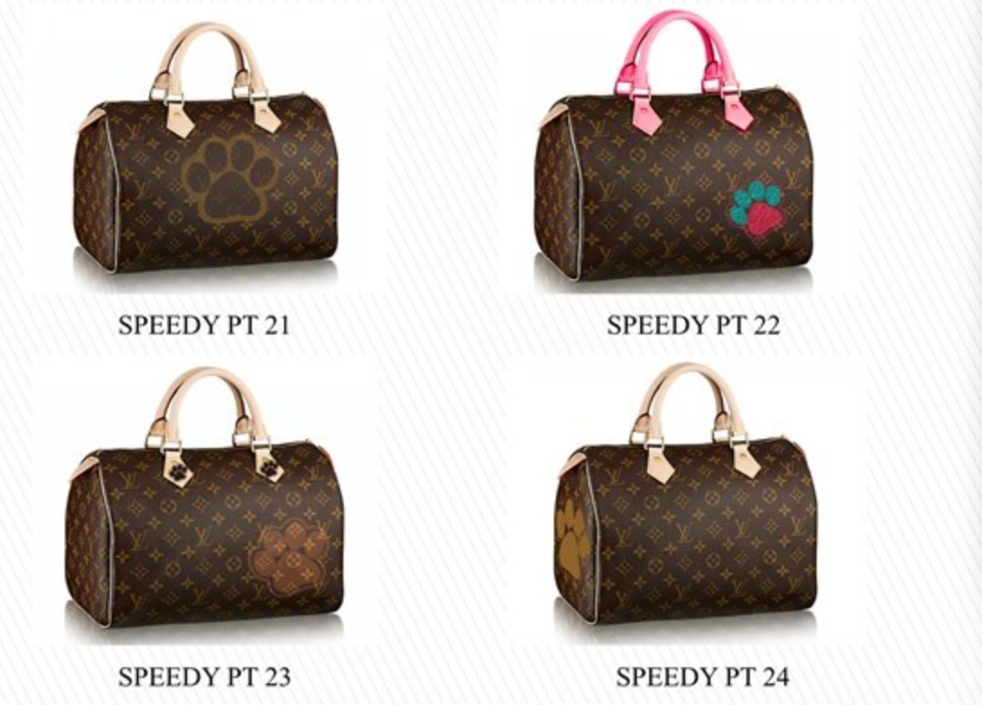
The collection shows to you in the following of picture (figure 1)

Figure 1

Now need to create the “Cost Sheet” about this collection.

PLEASE CREATE AN COST SHEET, MUST HAVE 3 COSTING SCENARIOS. .

WHOLESALE UNITS, SELL PRICE AND RETAIL SELL PRICE MUST BE FILLED IN.

You may input your Bill Of Materials details and input costs by item, or input single Bill Of Materials line item cost and single BOL line item cost - which together is your negotiated FOB.

Then, Duty rate, commission and/or agent & freight cost is required.

Make sure you change the names of the costing scenarios and set the currency. I will deduct points if I don't see this! I also need to see the differences in the cost sheets. Can be Vendor or Construction changes.

The “Cost Sheet” should include the information that shows to you at following of pictures.

Try to fill all blanks at above pictures.

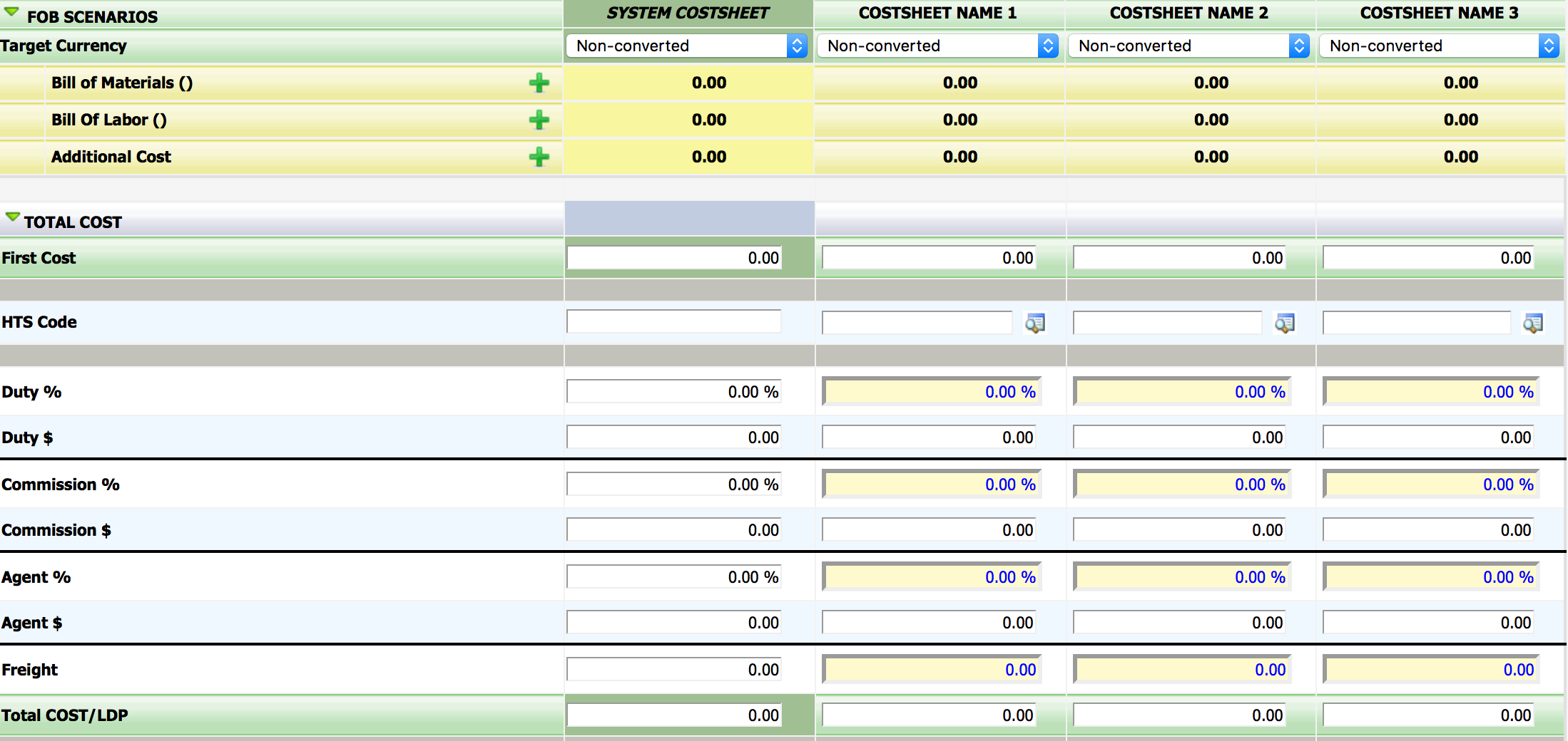
Also I will attach an example to you. Check it out, and get some ideas from the example.

